Module 3: Machine Learning Model Development
Question 1: How can we calculate the probability of loan approval using Logistic Regression?
Logistic Regression.
Formula: Logistic (Sigmoid) Function
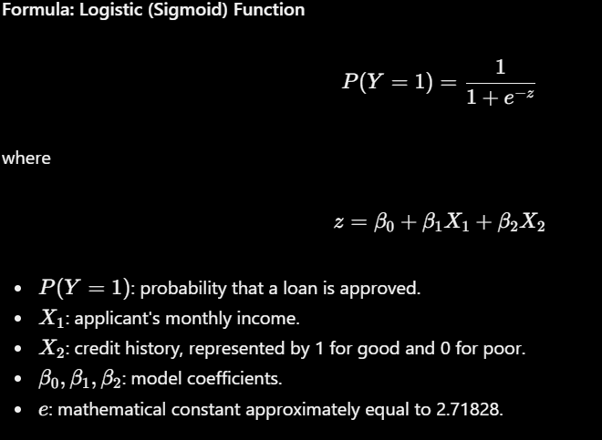
Why do we use this formula?
The linear expression \(z\) can produce any number, including negative values or values greater than 1. However, a probability must be between 0 and 1.
The sigmoid formula converts the linear result into a probability. We can then classify the application as approved or rejected using a threshold, commonly 0.5.
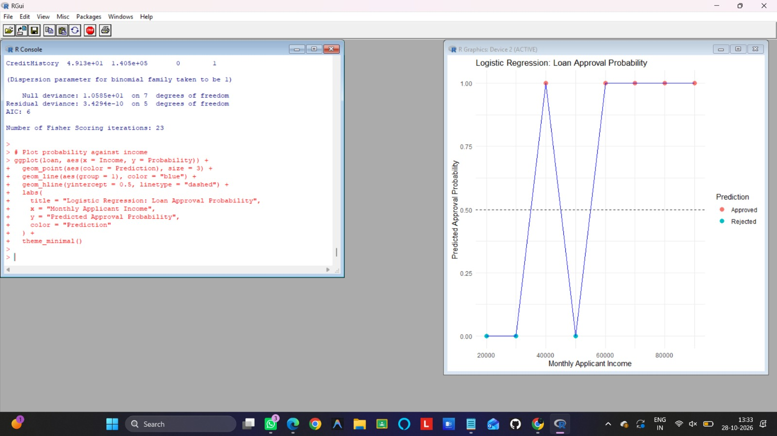
How to understand the output
- X-axis: applicant's monthly income.
- Y-axis: predicted probability of loan approval, from 0 to 1.
- Dashed line at 0.5: the classification threshold.
- Points: predicted probabilities for individual applicants.
A probability of 0.80 means the model estimates an 80% chance of approval. It does not guarantee that the loan will be approved.
Question 2: How can we calculate the odds of loan approval using Logistic Regression?
Module 3 — Logistic Regression.
Formula: Odds and Log-Odds

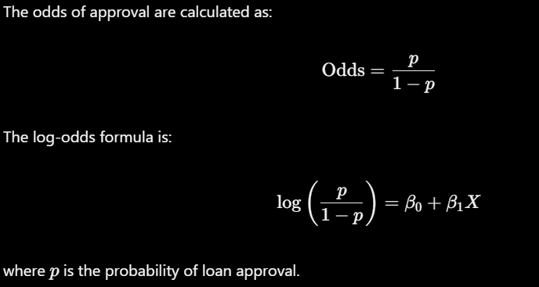
Why do we use this formula?
Probability tells us how likely approval is. Odds compare the likelihood of approval with the likelihood of rejection.
For example, if the probability of approval is 0.80:
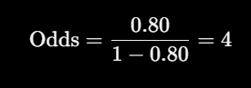
This means the estimated odds are 4 to 1 in favor of approval.
Logistic Regression uses log-odds because they can be modeled as a linear combination of applicant features.
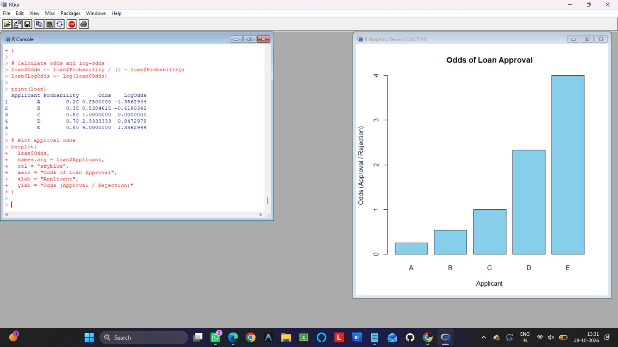
How to understand the output
- X-axis: applicants A to E.
- Y-axis: approval odds.
- Taller bars indicate higher odds of approval relative to rejection.
- Applicant E, with probability 0.80, has odds of 4.
Important: These are illustrative probabilities, not probabilities learned from a fitted model. This question explains how to interpret the Logistic Regression formula.
Question 3: How can a Decision Tree select the best feature for classifying loan applications?
Module connection: Module 3 — Decision Tree.
Formula: Gini Impurity
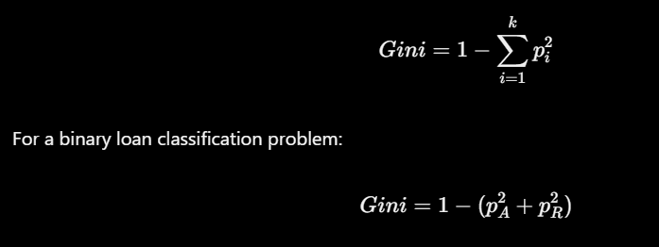where:
- (p_A): proportion of approved applications.
- (p_R): proportion of rejected applications.
- (k): number of classes.
Why do we use this formula?
A Decision Tree needs to choose how to split data into groups. Gini impurity measures how mixed the approved and rejected applications are within a group.
- Gini = 0: all records belong to one class.
- Higher Gini: the group contains a greater mixture of classes.
- A tree typically prefers splits that reduce weighted Gini impurity.
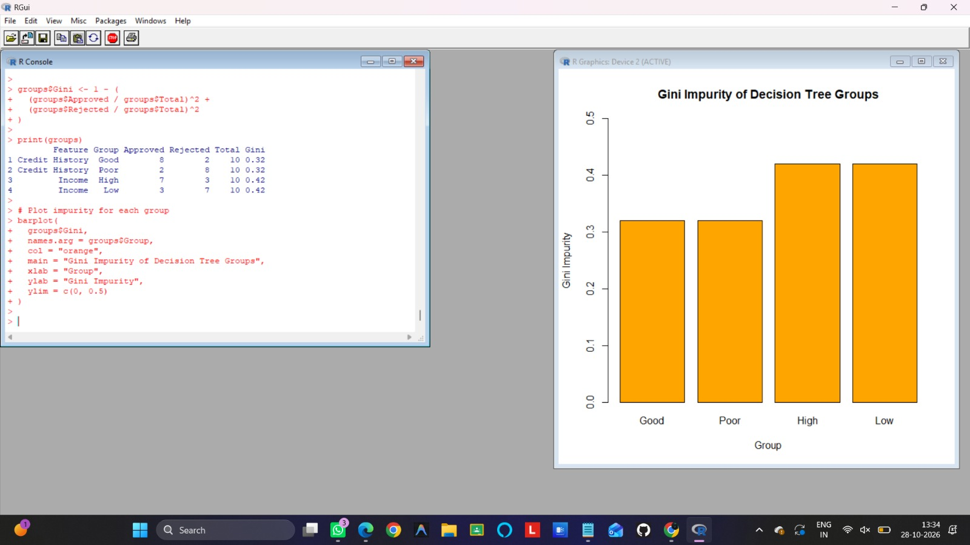
How to understand the output
- X-axis: groups created by potential feature splits.
- Y-axis: Gini impurity.
- Lower bars indicate purer groups.
- A group containing only approved or only rejected applications has Gini impurity of zero.
What is Gini Impurity?
Gini Impurity is a formula used in a Decision Tree to measure how mixed the classes are in a group.
The formula is:
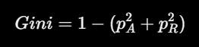
Where:
- (p_A) = proportion of approved loan applications.
- (p_R) = proportion of rejected loan applications.
Why do we use it? A Decision Tree uses Gini Impurity to help choose splits that separate approved and rejected applications into purer groups.

In this mock example, each group has a 20%/80% or 80%/20% class distribution, so every group has Gini impurity of 0.32.
Question 4: How can Random Forest combine predictions from multiple Decision Trees?
Module connection: Module 3 — Random Forest.
Formula: Majority Voting
For classification, the predicted class is the class receiving the most votes:
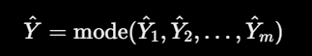
where:
- (hat{Y}): final predicted loan status.
(hat{Y}_i): prediction from tree (i).
- (m): number of trees.
Why do we use this formula?
A single Decision Tree may make an incorrect prediction. Random Forest combines predictions from many trees and chooses the class with the most votes.
This can improve prediction stability compared with relying on just one tree, although improvement is not guaranteed for every dataset.
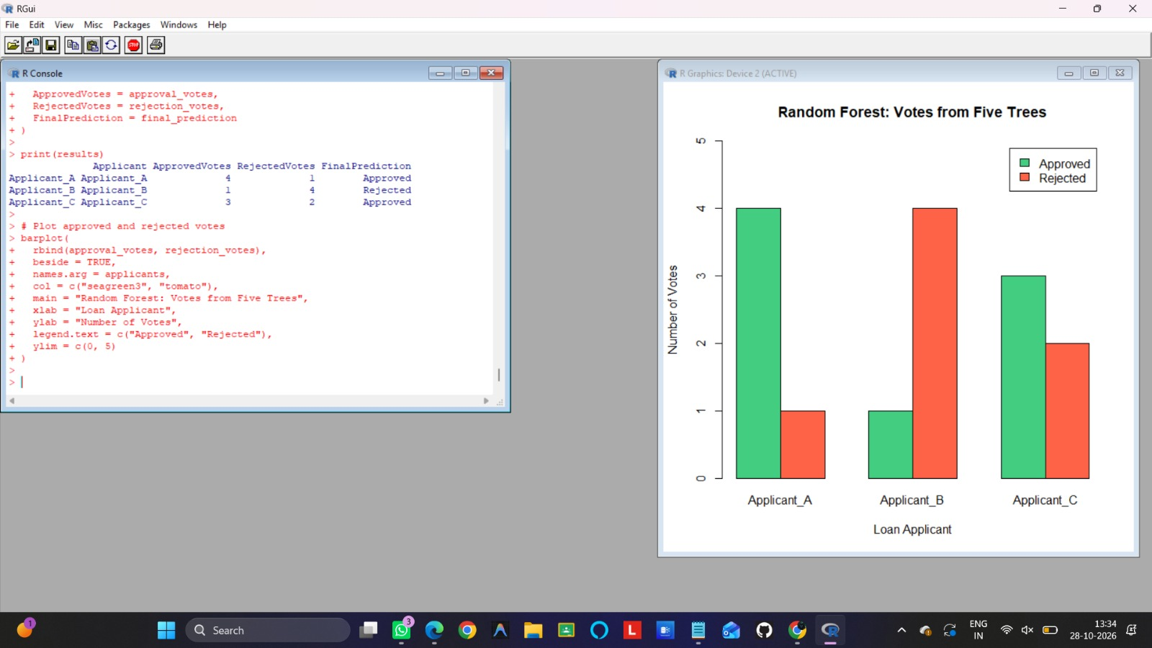
How to understand the output
- X-axis: the three loan applicants.
- Y-axis: number of tree votes.
- Green bars represent approval votes.
- Red bars represent rejection votes.
For Applicant A, four trees vote for approval and one votes for rejection. The final prediction is therefore Approved.
This code demonstrates the voting principle with mock tree predictions; it does not train an actual Random Forest model.

Question 5: How can we calculate the accuracy of a trained loan approval model?
Module 3 — Machine Learning Model Development
Formula: Classification Accuracy
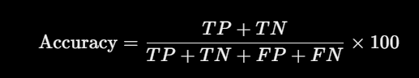
where:
- (TP): approved applications correctly predicted as approved.
- (TN): rejected applications correctly predicted as rejected.
- (FP): rejected applications incorrectly predicted as approved.
- (FN): approved applications incorrectly predicted as rejected.
Why do we use this formula?
After developing a model, we need to determine how often its predictions match the actual loan status.
Accuracy gives the percentage of correct predictions. It can help compare Logistic Regression, Decision Tree, and Random Forest models, but it may be misleading when approved and rejected applications are highly imbalanced.
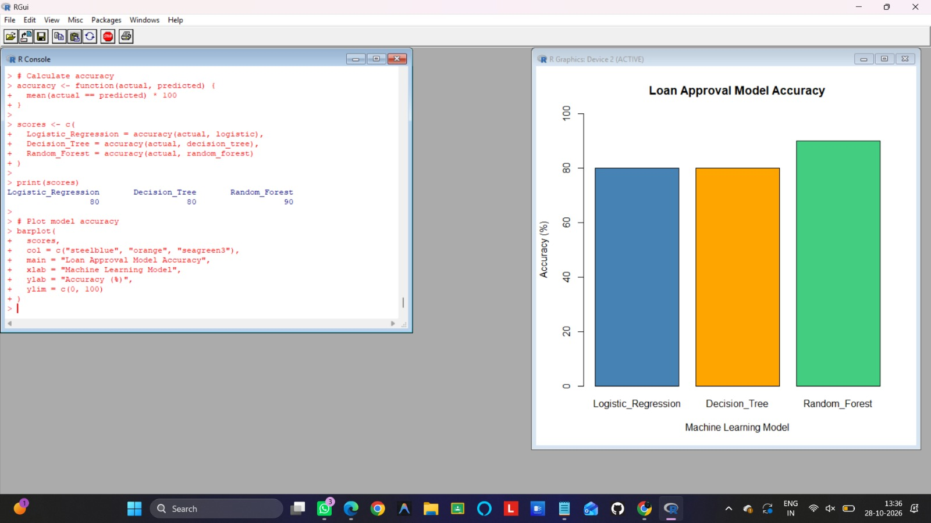How to understand the output
- X-axis: the three machine learning models.
- Y-axis: percentage of correct predictions.
- A taller bar means a higher accuracy on the mock test data.
For this example, the expected output is:
Model | Correct predictions | Accuracy
Logistic Regression | 8 out of 10 | 80%
Decision Tree | 8 out of 10 | 80%
Random Forest | 9 out of 10 | 90%
Random Forest achieves the highest accuracy in this mock example. This does not establish that it will perform best on real loan data.
Important: The code uses manually created predictions to demonstrate the formula. To measure actual model performance, train each algorithm on a training dataset and evaluate its predictions on a separate test dataset.

